Compsci 557 Homework 6

Kayla Goetzke

Phil Sauvey

Chapter 10 # 1, 6, 8, 9

1A) There are 2 database requests required for an inventory update.

1B)

UPDATE PRODUCT

SET PROD_QOH = PROD_QOH +1

WHERE PROD_CODE = "ABC";

UPDATE PART

SET PART_QOH = PART_QOH - 1

WHERE PART_CODE = "A" OR

PART_CODE = "B" OR

PART_CODE = "C";

1C)

BEGIN TRANSACTION

UPDATE PRODUCT

SET PROD_QOH = PROD_QOH +1

WHERE PROD_CODE = "ABC";

UPDATE PART

SET PART_QOH = PART_QOH - 1

WHERE PART_CODE = "A" OR

PART_CODE = "B" OR

PART_CODE = "C";

COMMIT;

1D)

|  |  |  |  |  |  |  |  |  |  |
| --- | --- | --- | --- | --- | --- | --- | --- | --- | --- |
| TRL_ID | TRX_NUM | PREV_PTR | NEXT_PTR | OPERATION | TABLE | ROW_ID | ATTRIBUTE | BEFORE VALUE | AFTER VALUE |
| 14 | 5 | NULL | 24 | START | **START TRANSACTION |  |  |  |  |
| 24 | 5 | 14 | 27 | UPDATE | PRODUCT | ABD | PROD_QOH | 77 | 78 |
| 27 | 5 | 24 | 28 | UPDATE | PART | A | PART_QOH | 53 | 52 |
| 28 | 5 | 27 | 29 | UPDATE | PART | B | PART_QOH | 42 | 41 |
| 29 | 5 | 28 | 33 | UPDATE | PART | C | PART_QOH | 1 | 0 |
| 33 | 5 | 29 | NULL | COMMIT | ** END OF TRANSACTION |  |  |  |  |

1E)

1. Find the commit TRL_ID 33
2. Using PREV_PTR find the start of the transaction, TRL_ID 14
3. Using NEXT_PRT find each update operation and apply the changes to the disk using the AFTER VALUE, TRL_IDs 24, 27, 28, and 29
4. Repeat for any other transaction.

6A)

BEGIN TRANSACTION

INSERT INTO INVOICE

VALUES(

10983,

10010,

'11-MAY-2016',

118.80,

"30",

"OPEN");

INSRT INTO LINE

VALUES(10983, 1, '11QER/31', 1, 110.00);

UPDATE PRODUCT

SET P_QTYOH = P_QTYOH - 1,

WHERE P_CODE = "11QER/31";

UPDATE CUSTOMER

SET CUS_BALANCE = CUS_BALANCE + 118.80,

CUS_DATELSTPUR = "11-MAY, 2016"

WHERE CUS_CODE = 10010;

COMMIT;

6B)

BEGIN TRANSACTION

INSERT INTO PAYMENTS

VALUES(

3428,

"03-JUN-2016",

10010,

100.00,

"CASH",

"N/A");

UPDATE CUSTOMER

SET CUS_BALANCE = CUS_BALANCE - 100.00,

CUS_DATELSTPAY = "03-JUN, 2016"

WHERE CUS_CODE = 10010;

COMMIT;

8)

|  |  |
| --- | --- |
| Time | Step |
| 1 | Lock INVOICE |
| 2 | Insert row 10983 into INVOICE |
| 3 | Unlock INVOICE |
| 4 | Lock LINE |
| 5 | Insert into row 10983, 1 into LINE |
| 6 | Unlock LINE |
| 7 | Lock PRODUCT |
| 8 | Update PRODUCT 11QER/31, P_QTYOH from 47 to 46 |
| 9 | Unlock PRODUCT |
| 10 | Lock CUSTOMER |
| 11 | Update CUSTOMER 10010, CUS_BALANCE from 345.67 to 464.47 |
| 12 | Update CUSTOMER 10010, CUS_DATELSTPUR from 05-May-2010 to 11-May-2012 |
| 13 | Unlock CUSTOMER |

9)

|  |  |
| --- | --- |
| Time | Step |
| 1 | Lock INVOICE |
| 2 | Lock LINE |
| 3 | Lock PRODUCT |
| 4 | Lock CUSTOMER |
| 5 | Insert row 10983 into INVOICE |
| 6 | Insert into row 10983, 1 into LINE |
| 7 | Update PRODUCT 11QER/31, P_QTYOH from 47 to 46 |
| 8 | Update CUSTOMER 10010, CUS_BALANCE from 345.67 to 464.47 |
| 9 | Update CUSTOMER 10010, CUS_DATELSTPUR from 05-May-2010 to 11-May-2012 |
| 10 | Unlock INVOICE |
| 11 | Unlock LINE |
| 12 | Unlock PRODUCT |
| 13 | Unlock CUSTOMER |

Chapter 11 # 1, 2, 4, 5, 6

1) There are only two possible outcomes for the EMP_SEX column, M or F. Therefore, EMP_SEX has low sparsity.

2) Based on the code, we should create indexes in EMP_AREACODE and a combination of EMP_LNAME and EMP_FNAME.

INDEX 1:

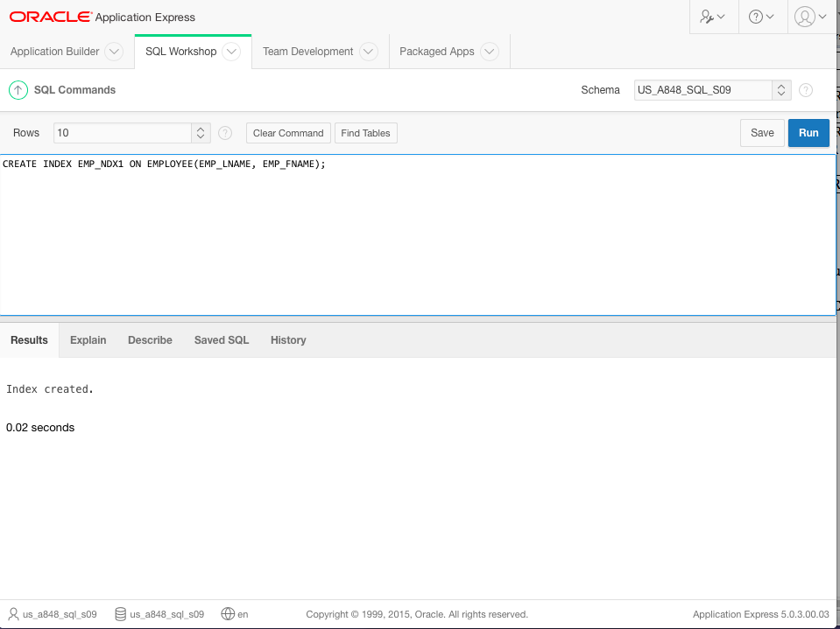

INDEX 2:

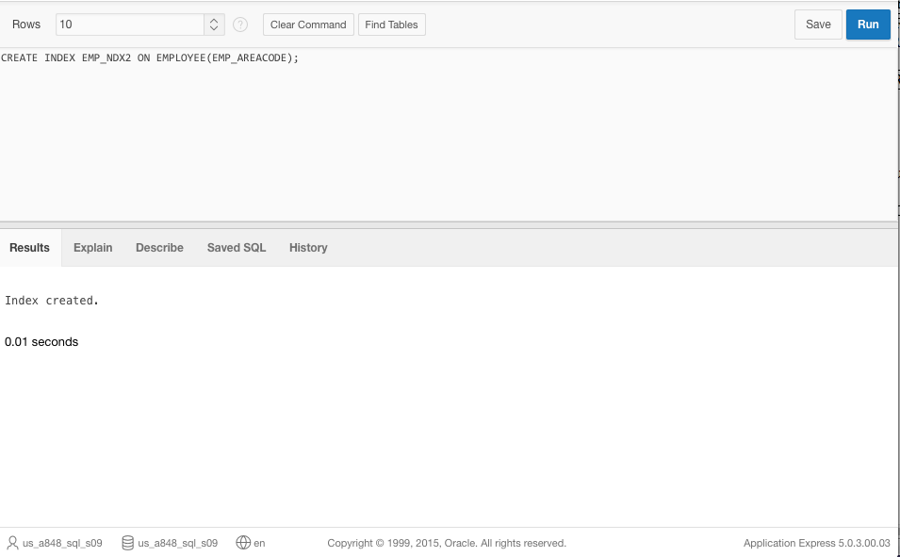

4)The EMP_DOB will have a high data sparsity because there are many different birthdates out there.

5)If you create an index in EMP_DOB, it will not help this query because it uses the YEAR function.

6) It will probably use the Table Scan (Full) to read in all the rows of the EMPLOYEE table. The first operation in the table 11.3.